CONFIGURE CLASSIC LOAD BALANCER.

LOAD BALANCER TASKS
|Go To Aws ConsoleLogin Ec2 ServiceLoad BalancingLoad Balancers
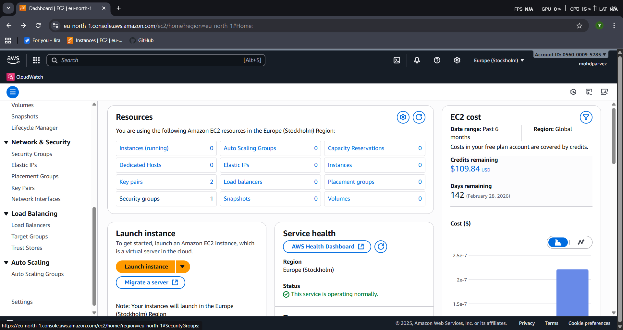|Click on create load balancer
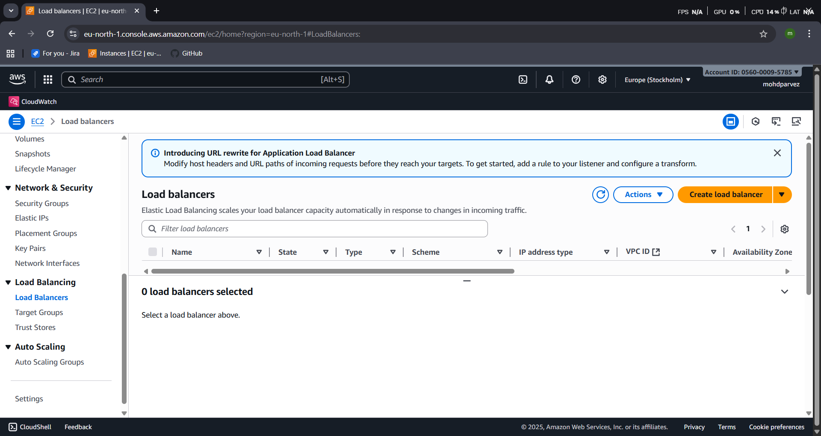

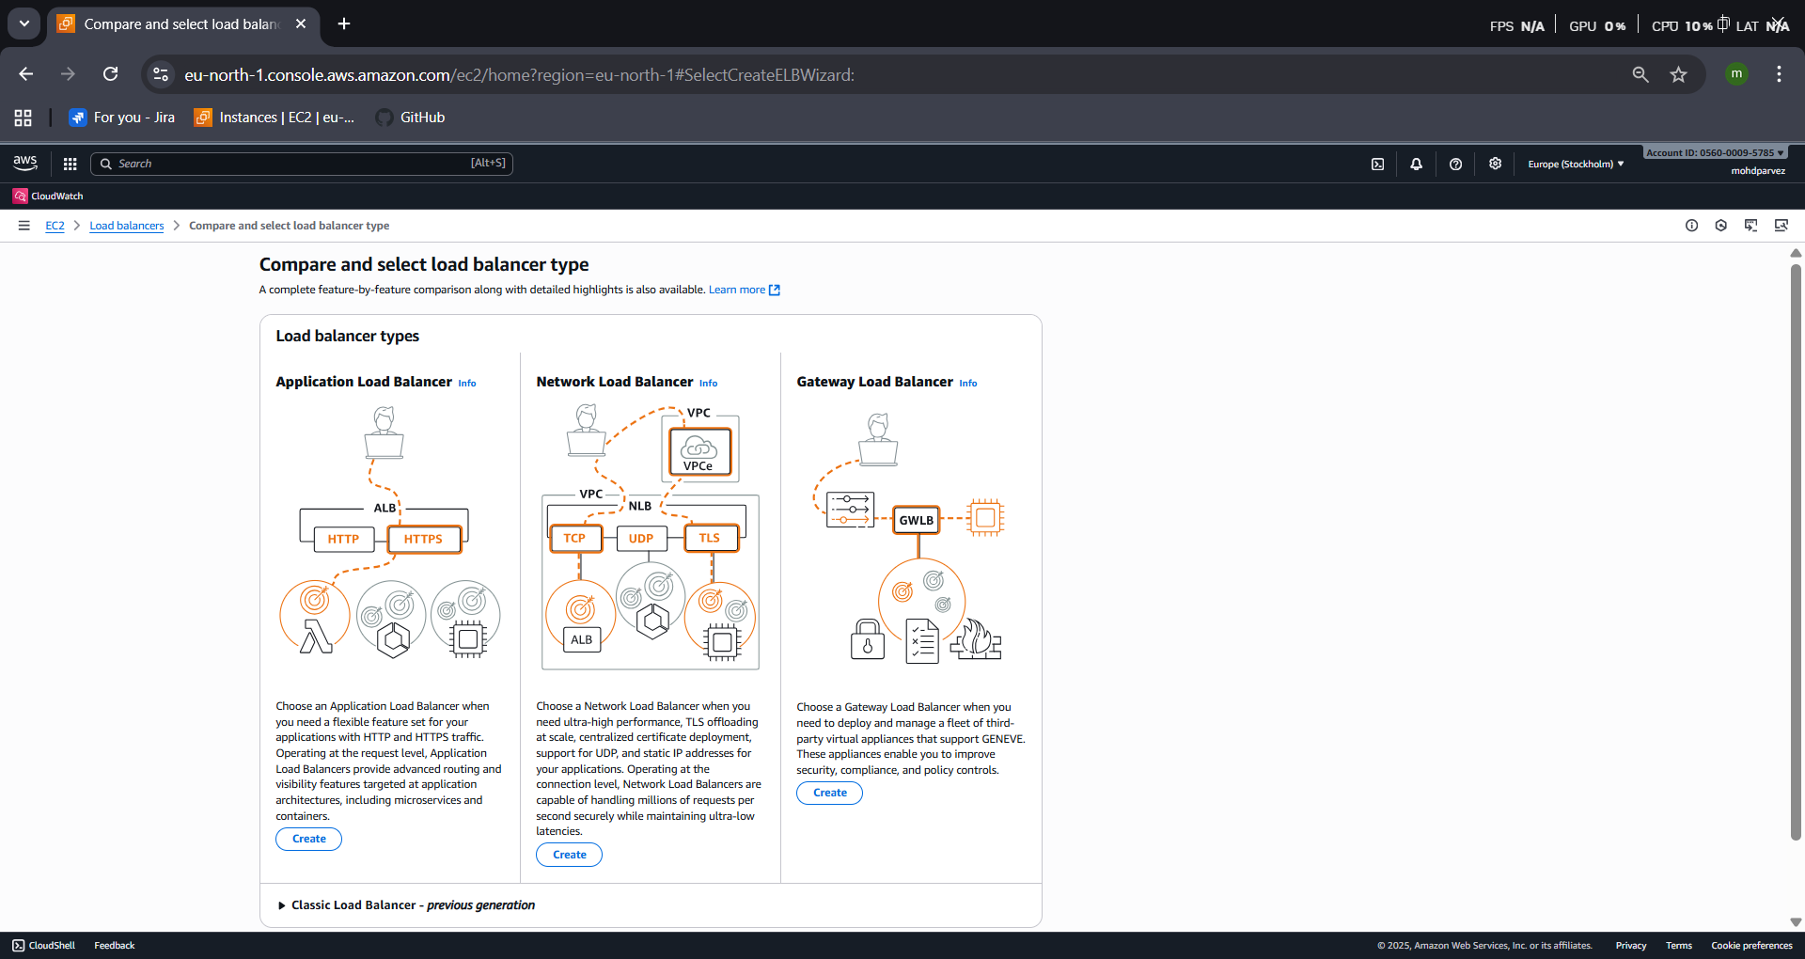
- |Select create classic load balancer
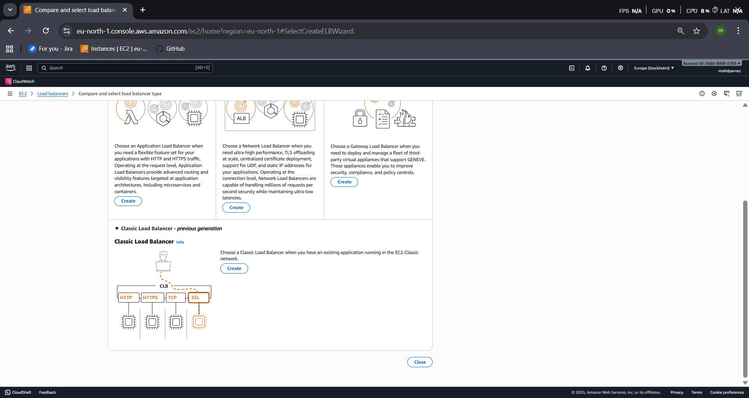
- |Name of the load balncer
|scheme – INTERNET FACING
Internet-facing Internal
• Serves internet-facing traffic. Has private IP addresses.
• Has public IP addresses. DNS name resolves to private IPs
• DNS name resolves to public IPs. DNS name resolves to private IPs.
• Requires a public subnet.
• Serves internal traffic.

|Network mapping
The load balancer routes traffic to targets in the selected subnets, and in accordance with your network settings.
VPCInfo
loadBalancers.vpcDescriptionClbInternal
Learn more
|Select a VPC – select the vpc default or create as required
Create VPC
|Availability Zones and subnets –select the availability zones for the load balancer to be created.
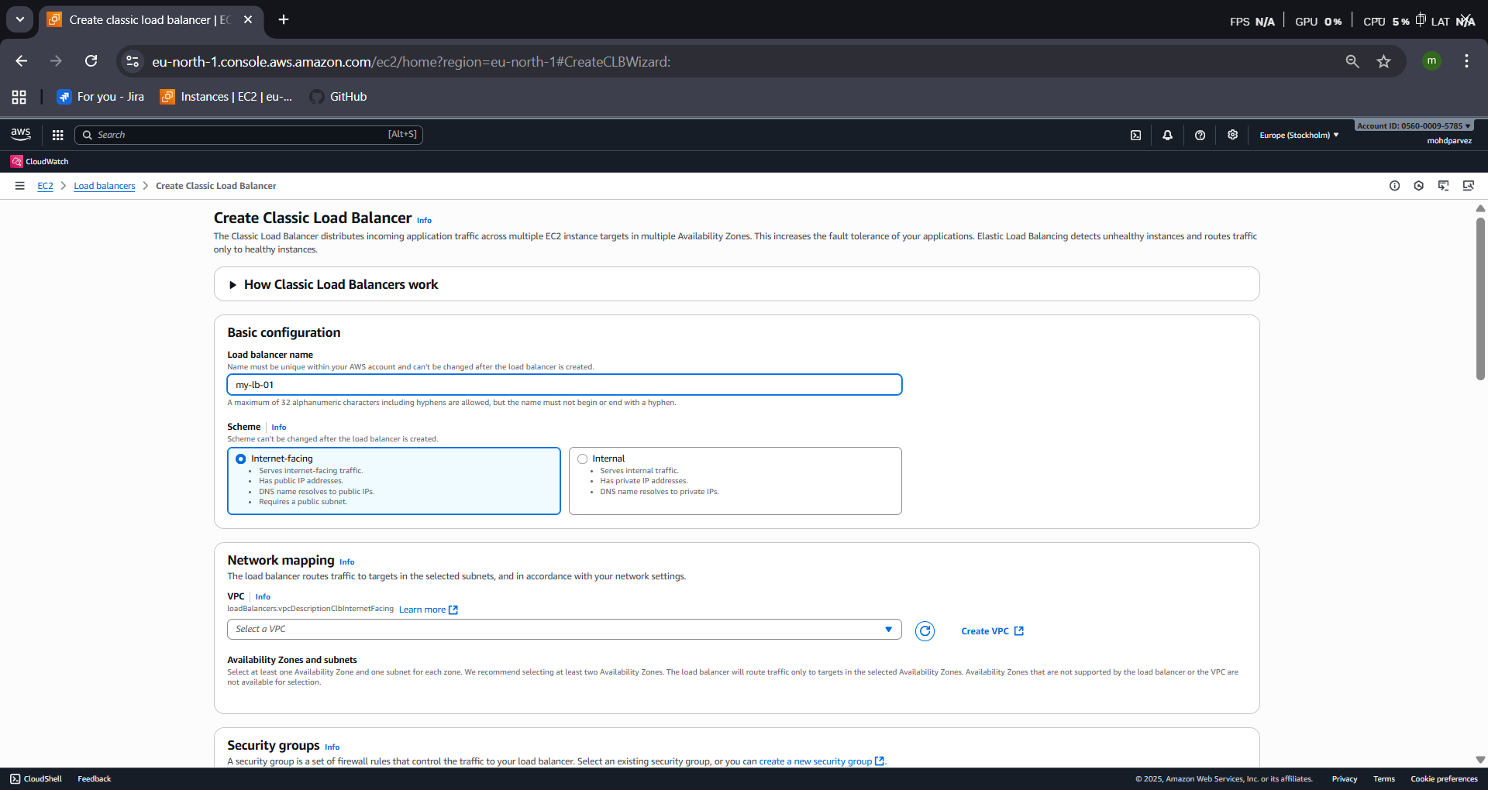
Select at least one Availability Zone and one subnet for each zone. We recommend selecting at least two Availability Zones. The load balancer will route traffic only to targets in the selected Availability Zones. Availability Zones that are not supported by the load balancer or the VPC are not available for selection.

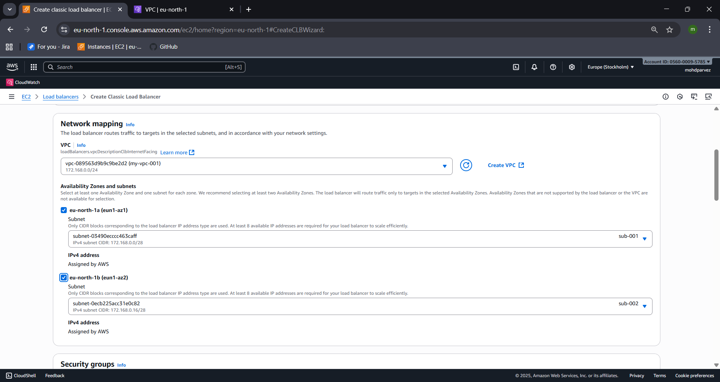
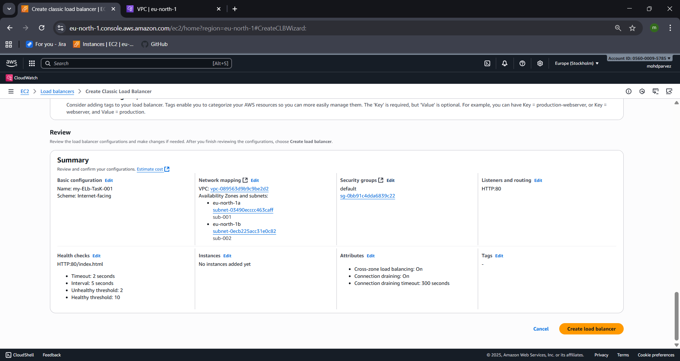
|one classic load balancer is created
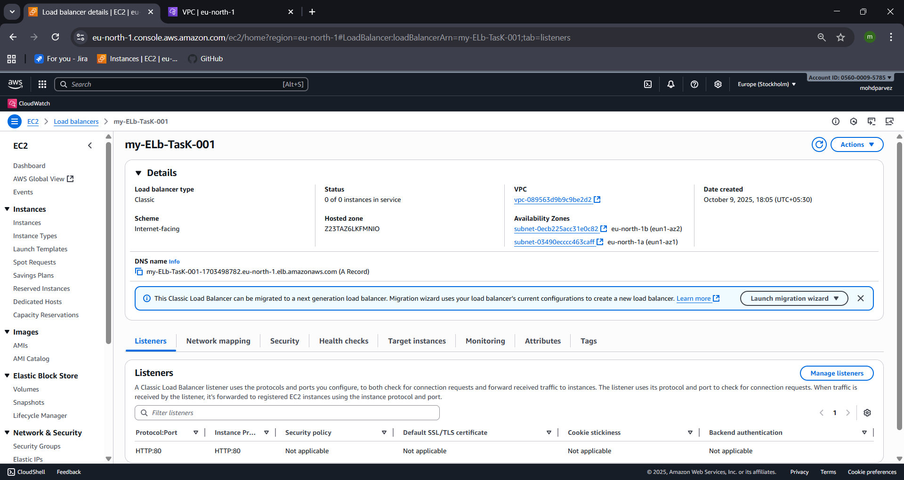
| configure the instances to the classicgo to elbactionsmanage instancesattach instances and save
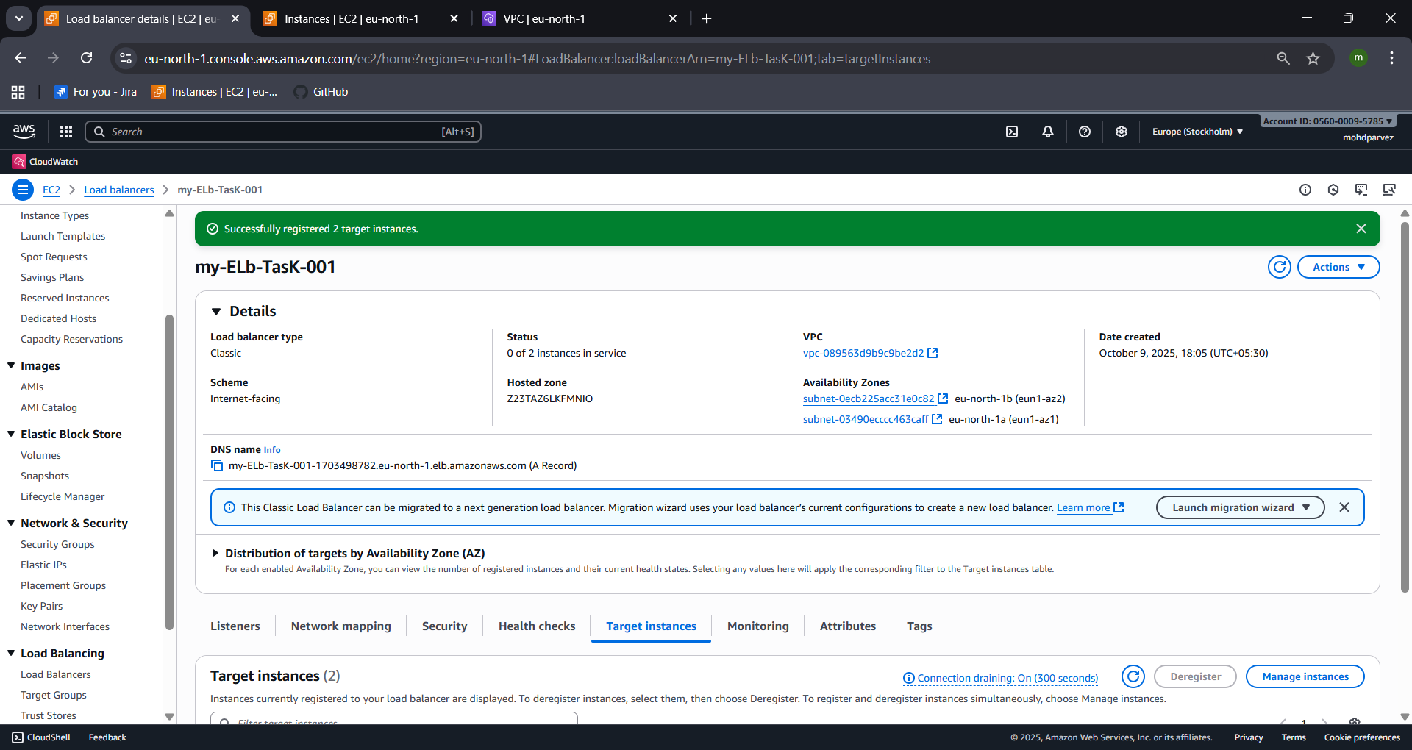
|connect to the ec2 instance and install nginx and check with public ip

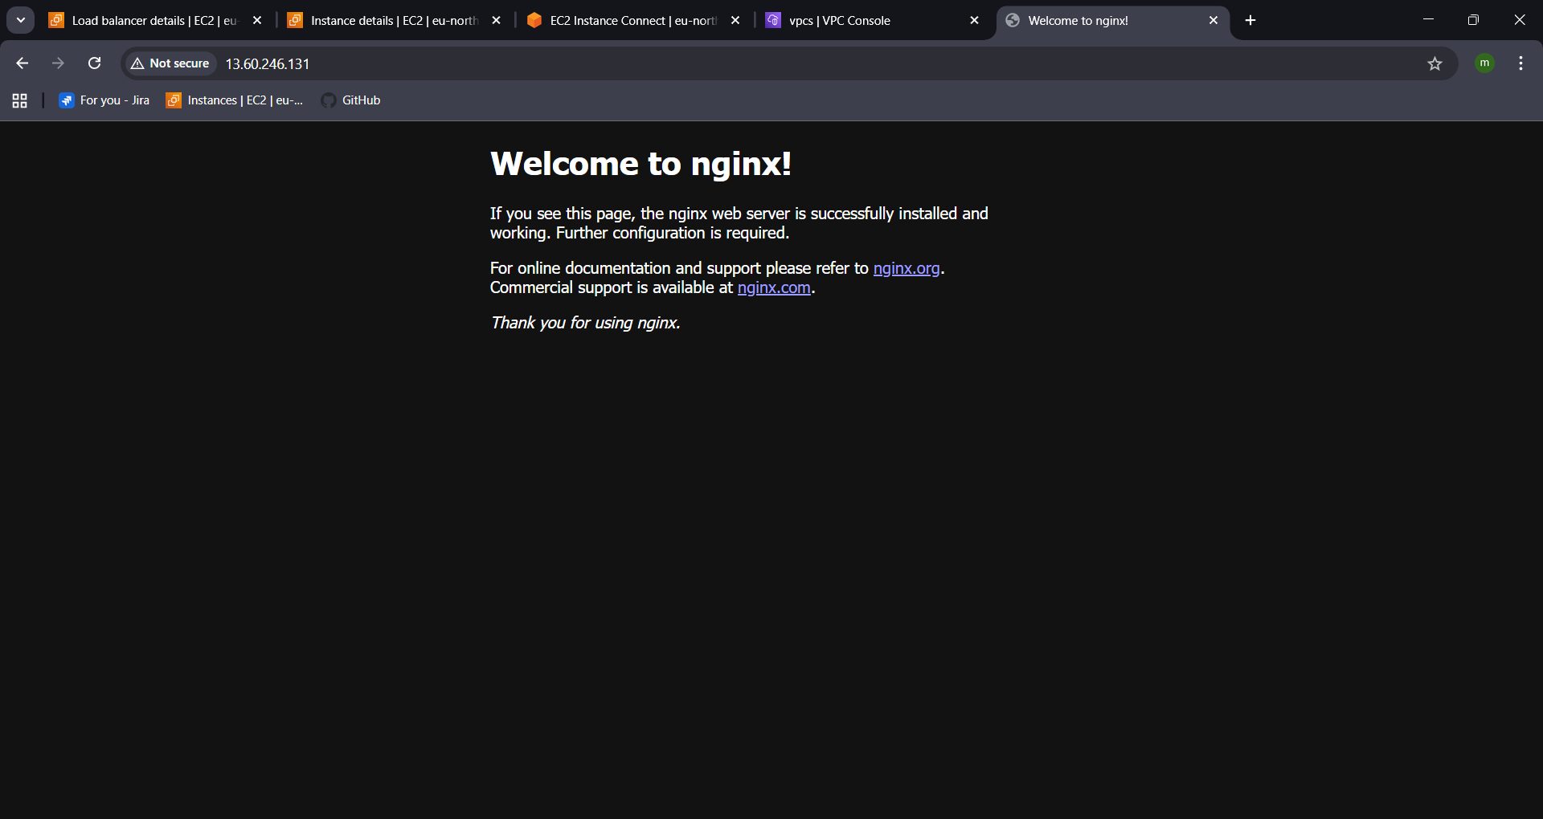
|now try to connect with the dns of the load balancer you created
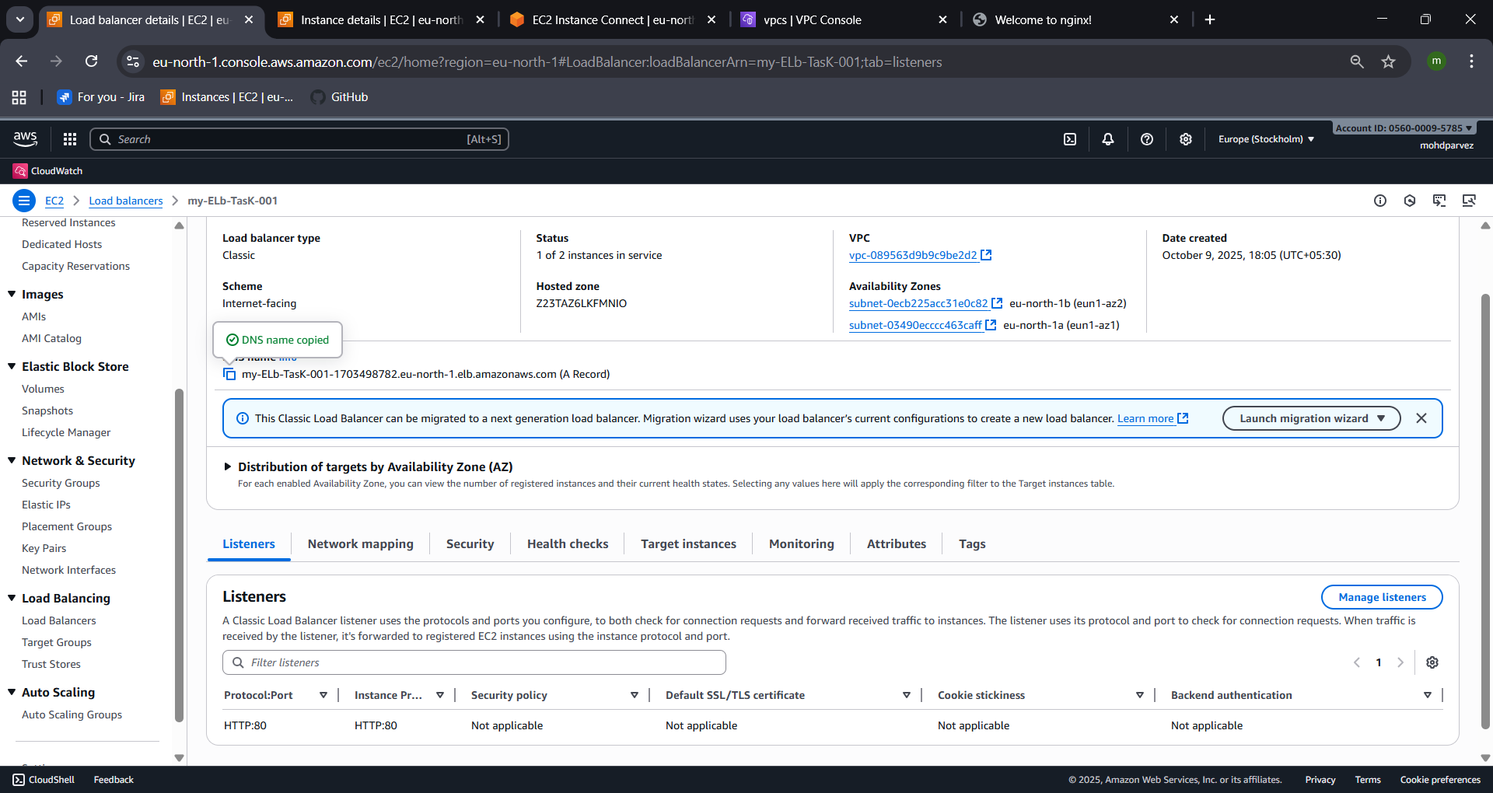
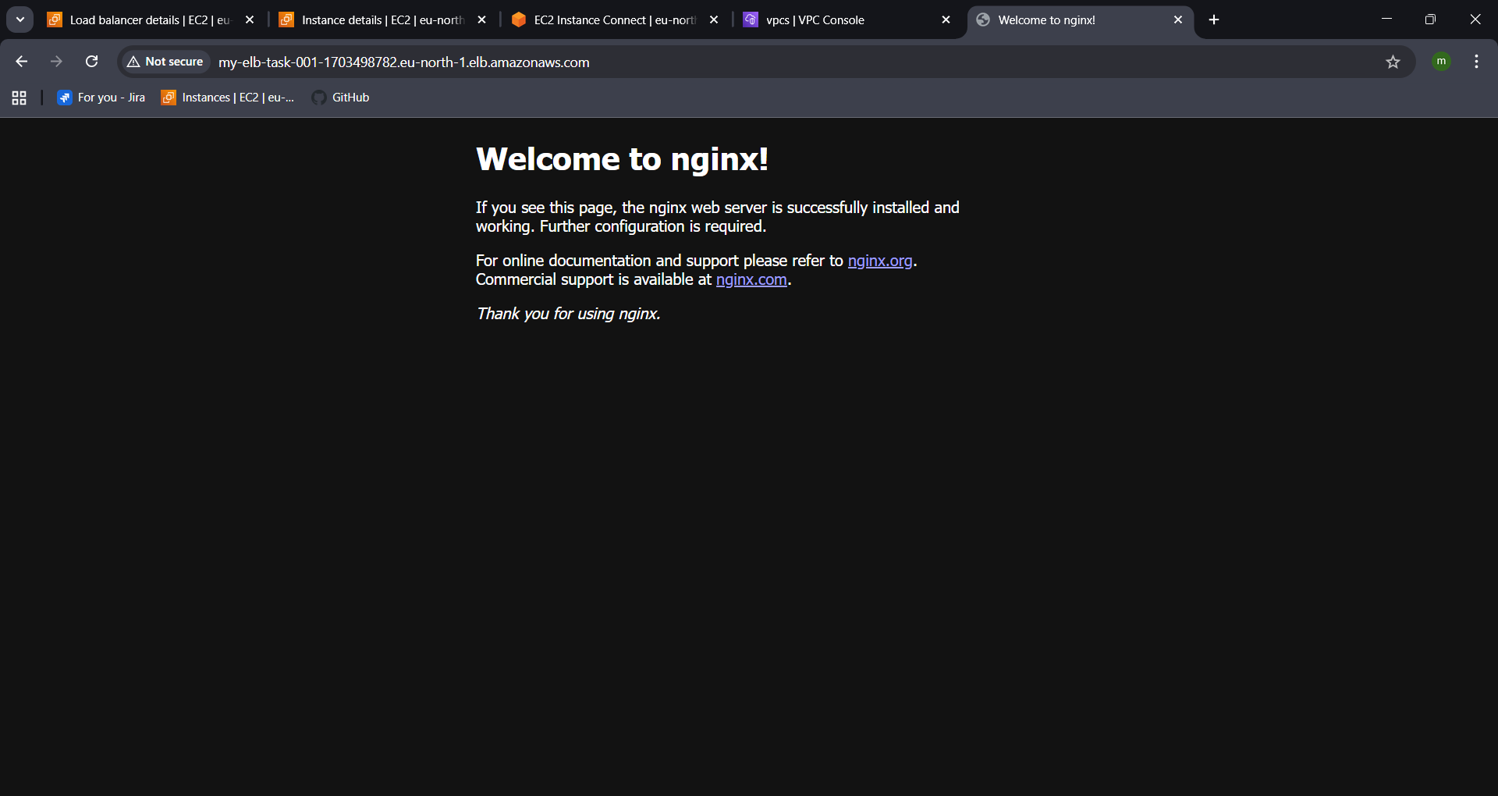

CONFIGURE APPLICATION LOAD BALANCER.
|Launch Two Instances In Two Different AZ(Availability Zone)
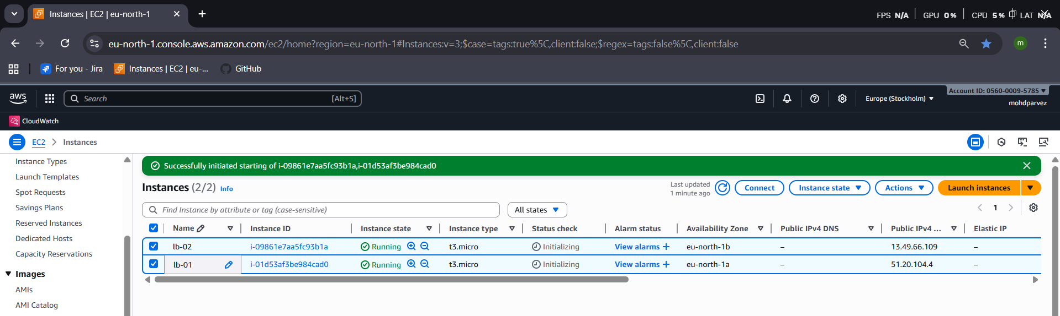
|Create Load Balancer Application Load Balancer
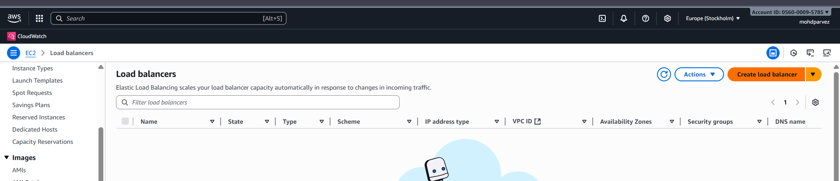
|create an application load balancer

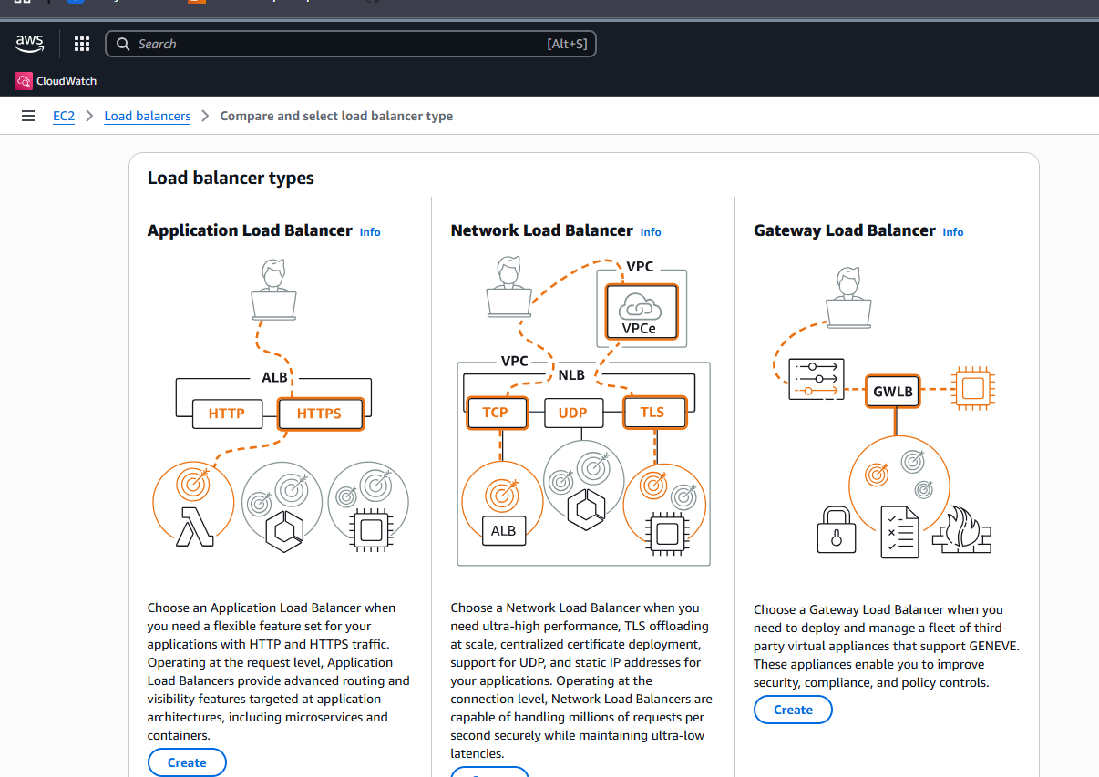
|add listenerstarget groups create and add target goupsselect vpcselect Az
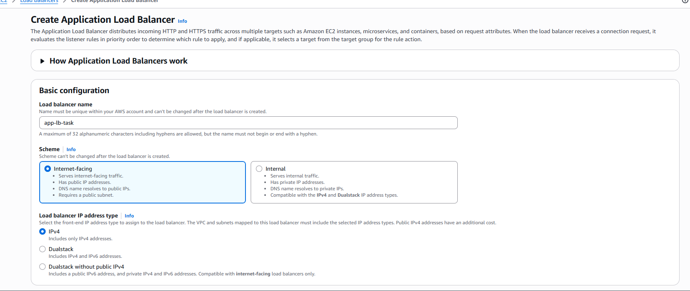
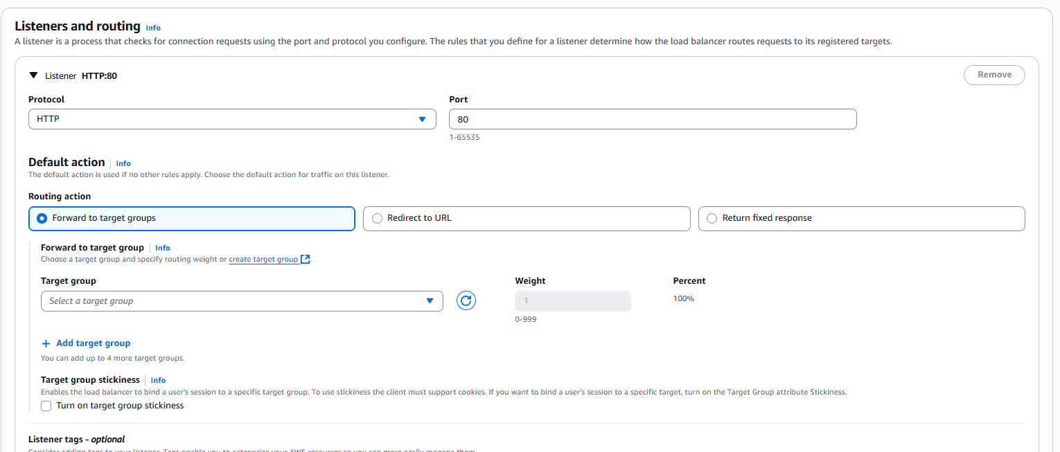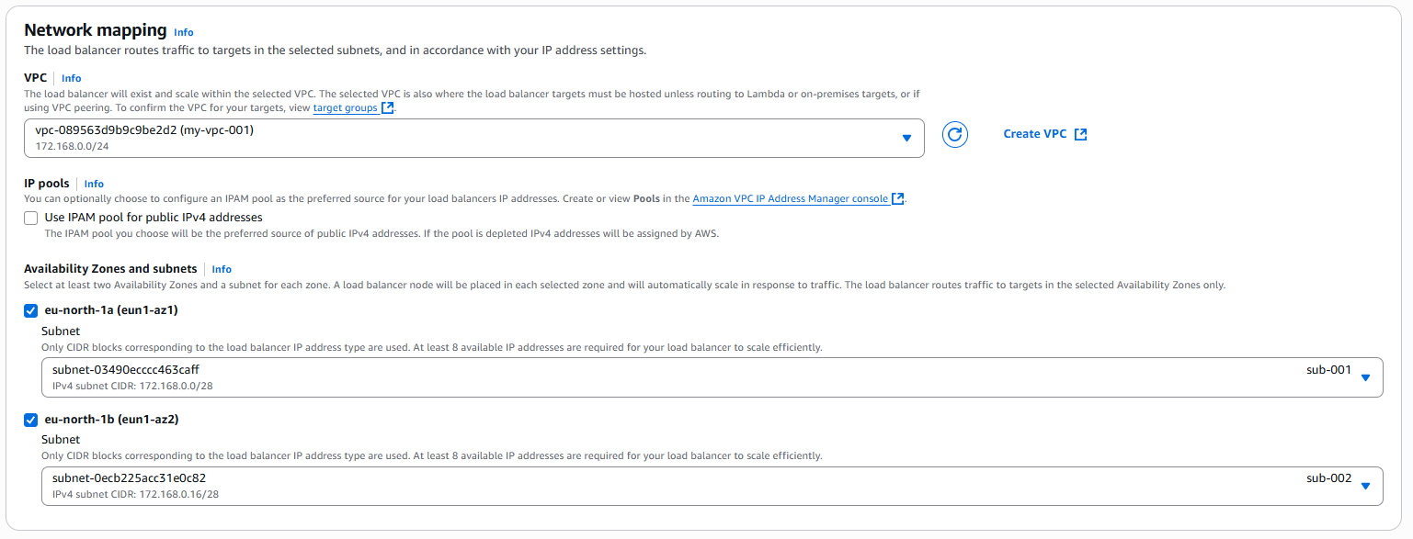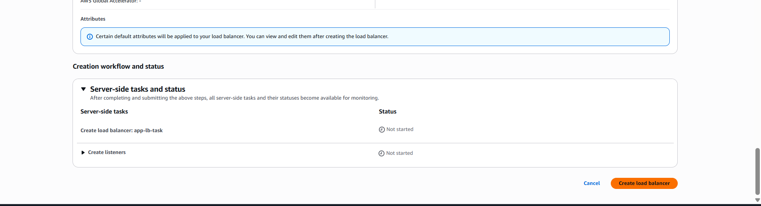
|make sure the targets are set to the ALB health checks are ok.
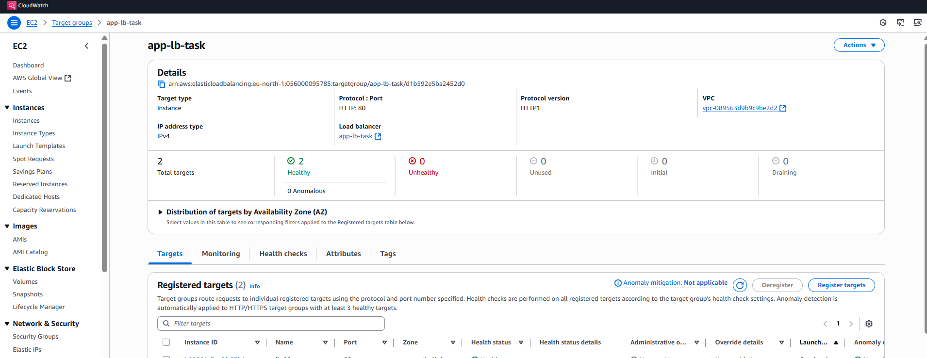
| copy the load balncer dns and checkit on browser it should redirect the web page you are hosting .
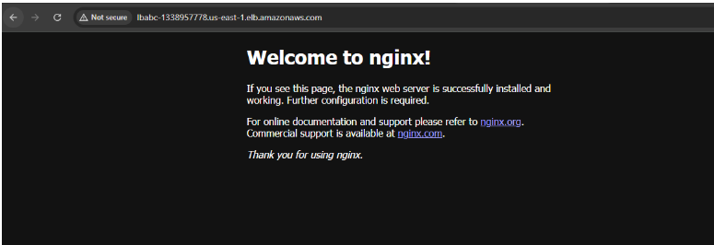

CONFIGURE NETWORK LOAD BALANCER.
|Select Network Load Balancer To Create
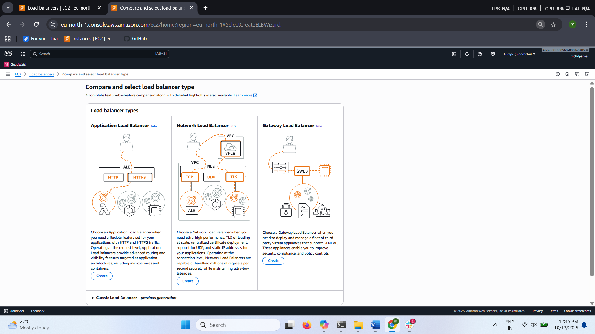
|Name Select VpcSubnetsSecurity GroupTarget Group Create Neetwork Load Balancer.
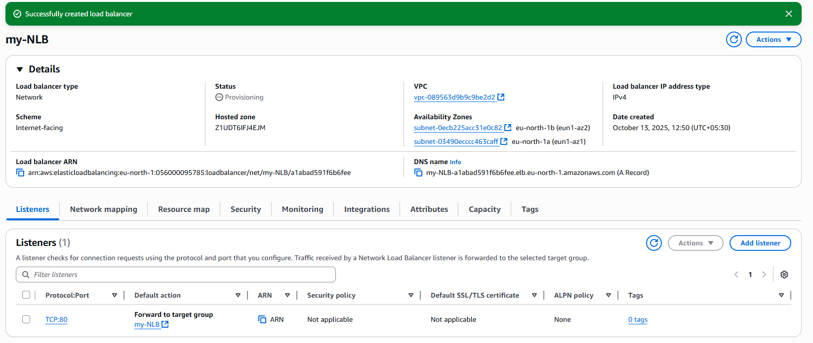
|Copy The Dns Name From The Load Balancer Check It In The Browser
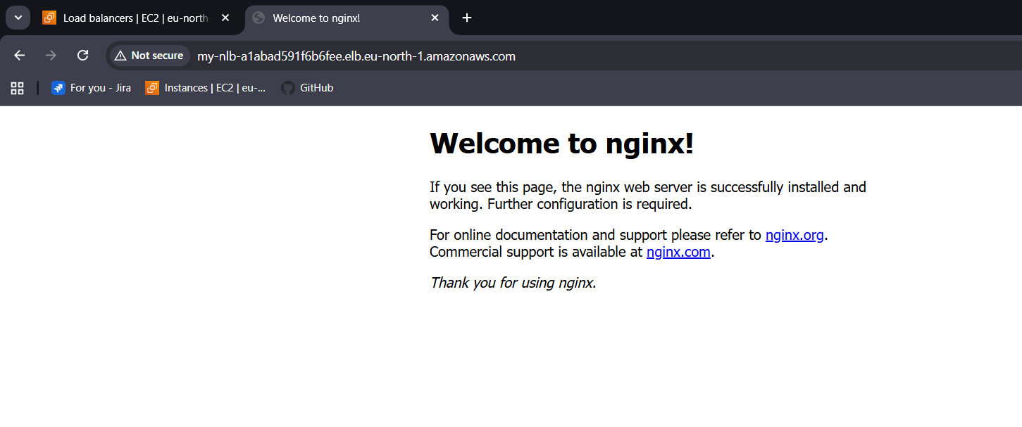

ATTACH SSL FOR APPLICATION LOAD BALANCER.
|go to cloud front create distributionselect origin as dns loadbalancernext create cloud front distribution
|add domainprovide domain namerequest for certificatethe certificate generated after validationattach it to the load balancer in integrations
|check your domain name in browser if it is working
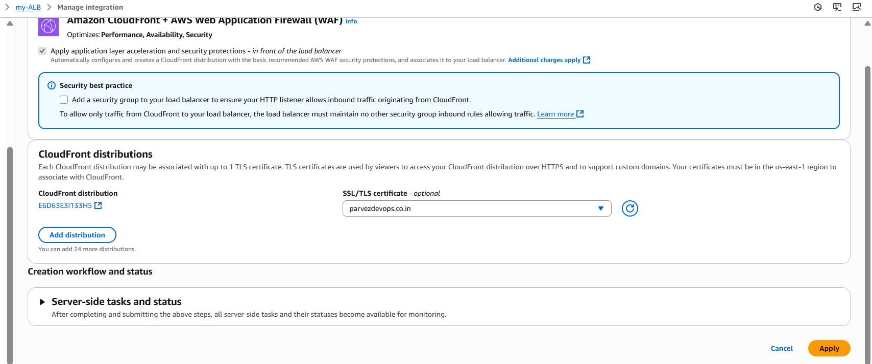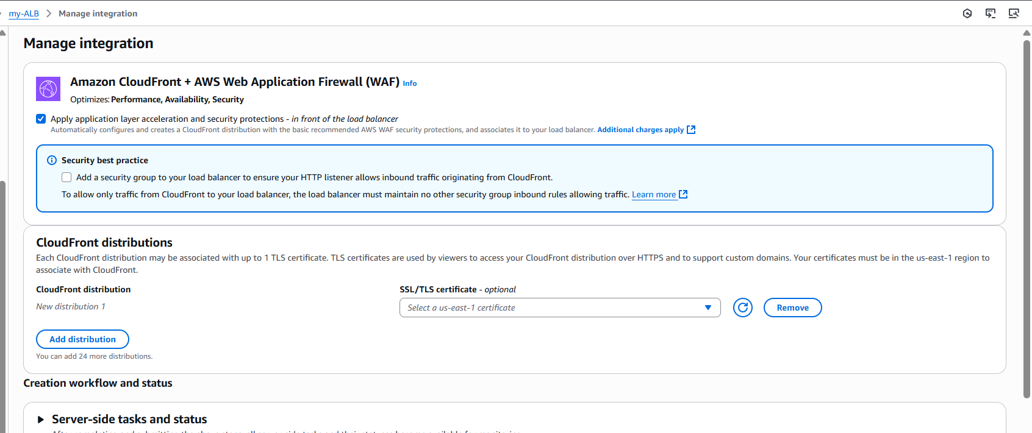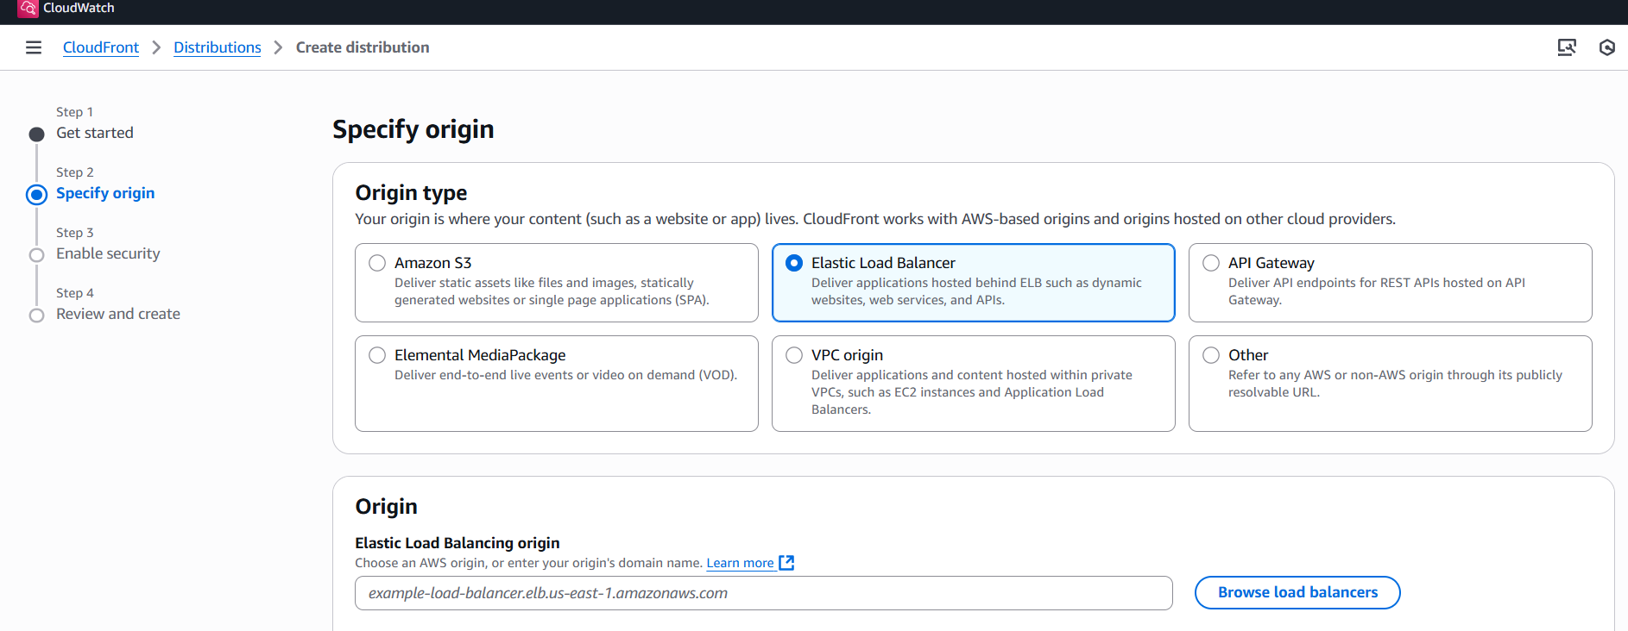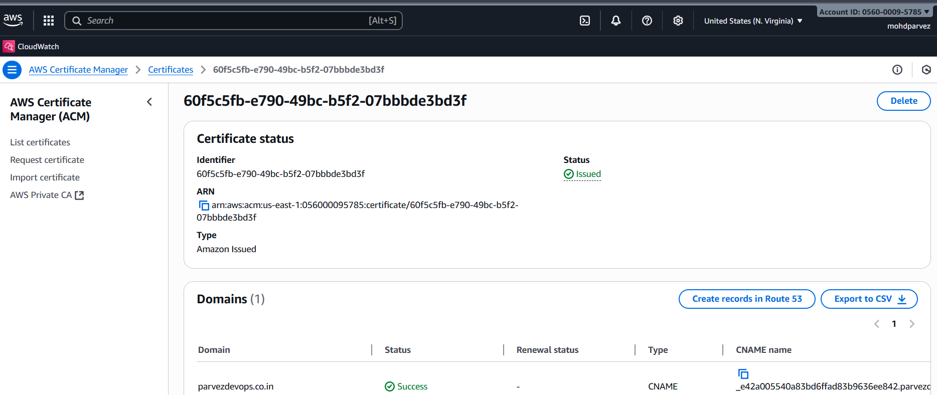
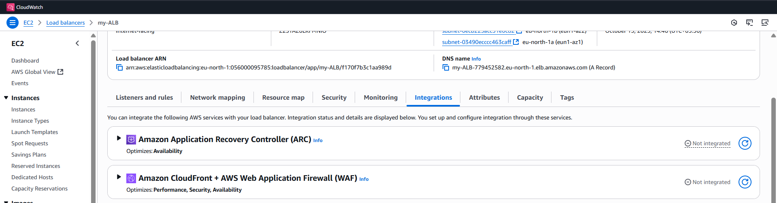

MAP APPLICATION LOAD BALANCER TO R53.
|go to route 53 create hosted zone with your domain name
|create records to redirect the load balancer dns to your domain name
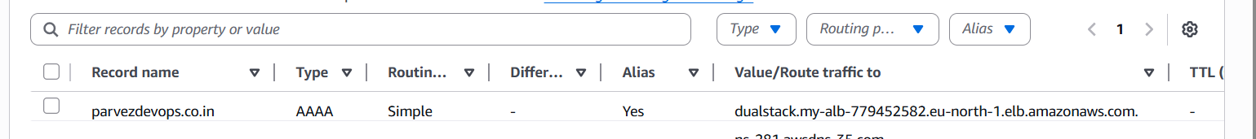

PUSH THE APPLICATION LOAD BALANCER LOGS TO S3
|go to s3 bucketbucket policy editpolicy to store the aws ALB logs in bucket
{
"Version":"2012-10-17",
"Statement": [
{
"Effect": "Allow",
"Principal": {
"Service": "logdelivery.elasticloadbalancing.amazonaws.com"
},
"Action": "s3:PutObject",
"Resource": "arn:aws:s3:::amzn-s3-demo-bucket/prefix/AWSLogs/123456789012/*"
}
]
}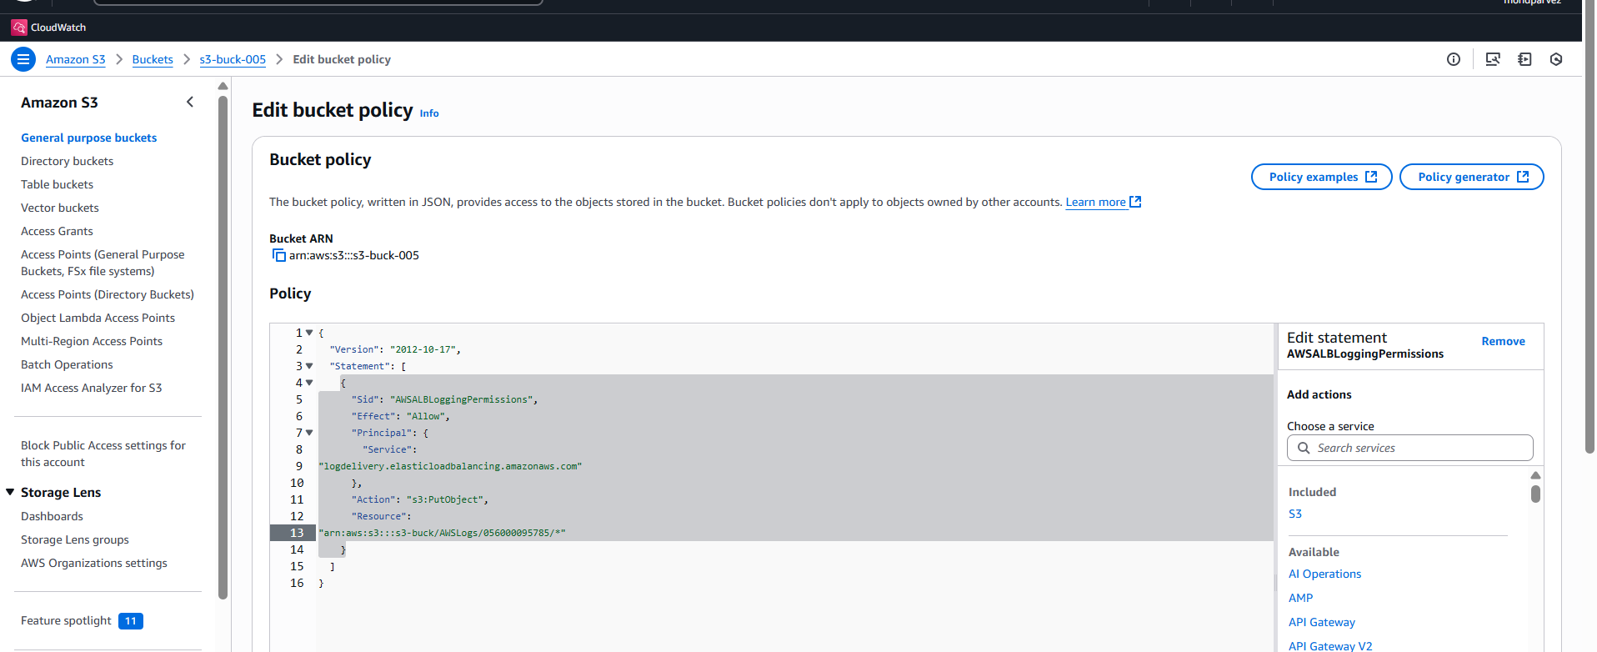
|go to application load balancer edit enamble acess logs --. Slelect bucket save the logs will be save din the s3 bucket
